AnglistenTheater
The AnglistenTheater of the University of Augsburg is an amateur student theatre group that has performed plays in English since 1980. It was founded by Rudolf Beck, then a lecturer in English literature, who produced and directed plays between 1981 and 1990. His successors were Ute Legner and Roger Evans, who directed their first play, Caryl Churchill’s Top Girls, in 1988. Ute Legner was in charge of the AnglistenTheater from 1991 to 2006. During her time more than 15 contemporary plays, were shown at the University and at the Abraxas theatre in Augsburg, many of them for the first time on a German stage. After an interval of 6 years, Rudolf Beck, in co-operation with Kellie Hirsch and Georg Hauzenberger, revived the AnglistenTheater in 2012 with Simon Stephens’ One Minute. – A list of the plays produced by the AnglistenTheater since 1981 can be found on our website http://www.student.uni-augsburg.de/de/gruppen/anglistentheater/.
If you would like to learn more about the AnglistenTheater, you may consult our website http://www.student.uni-augsburg. de/de/gruppen/ anglistentheater/, or follow us on Facebook: http:// www.facebook.com/ AnglistenTheaterAugsburg, or else subscribe to our mailing list by sending an email to phil-anglistentheater-subscribe@listserv.uni-augsburg.de and following the instructions in the reply.
If would like to become a member of the AnglistenTheater team, either on stage, or as part of the production team, please write us an email at anglistentheater@phil.uni-augsburg.de, or join us at our introductory meeting for the 2015/16 season
on Tuesday 7th July at 7:15 p.m. in rm 2127A (D building of the university).
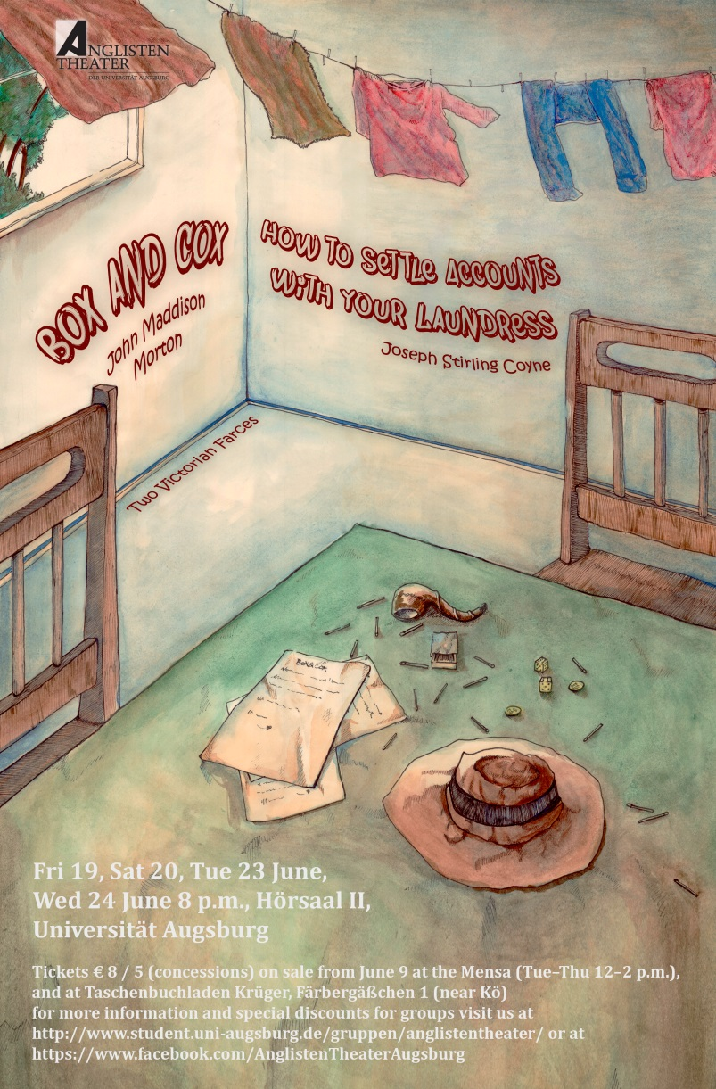

John Maddison Morton, Box and Cox
Cast in order of appearance
Cox | Daniel Ferrer
Mrs. Bouncer | Luise Hannig
Box | Stephan Schwarz
Penelope Ann Wiggins | Kathrin Bayer
P.A.W’s man of business | Jack Sigel
Joseph Stirling Coyne, How to Settle Accounts with Your Laundress
Cast in order of appearance
Twill, butler | Jack Sigel
Postgirl | Jorid Kretzschmar
Whittington Widgetts | Daniel Ferrer
Mary White, a laundress | Elena Renn
Brown, a hairdresser | Stephan Schwarz
Waitress | * * *
Cheri Bounce | Melanie Schuster
________________________________
Production Team
Technical directors | Christian Attinger  Georg Hauzenberger
Light and Sound | Roman Wirth, Kathrin Bayer, Jorid Kretzschmar, Elena Renn
Stage design | Cast and production team
Stage construction | Cast and production team
Sound design | Bettina Auerswald
Stage management | Lisa Bertmann
Prompt | Natalie Bertmann
Poster, Flyers, Tickets | Martin Desho
Publicity | Klaus Prem, Petra Müller, members of cast and production team
Facebook, twitter | Christian Attinger, Roman Wirth
Costumes | Christina Gohle, Lilly Rietzler, Signe Sturup-Hackenberg
Makeup, Hairstyle | Christina Gohle, Luise Hannig, Kathrin Bayer
Stage hands, front-of-house, ticket sale | Tanja Ponzer, Martin Riedelsheimer, Korbinian Stöckl, and others
Directed by | Rudolf Beck
There will be an interval of about 20 minutes between the plays.
Thanks are due to Martin Middeke, for his generous support, moral and otherwise; to the staff of the press and public relations office of the university; to Karin Bintakies for helping us book rehearsal and performance spaces, to Weinkellerei Bayerl for letting us have 100 wine crates for the set.
We regret that we cannot permit photographs, sound or video recordings of this performance to be taken by any means.
Odds and ends
Farce A type of comedy which employs highly exaggerated or caricatured characters, and makes free use of gross incongruities, sexual mix-ups, coarse wit, and horseplay. |  | 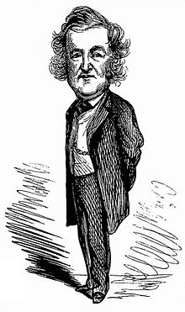  John Maddison Morton (1811-91)
In 19th C political satires, the characters of Box and Cox were often used to represent the two opposing British party leaders, Benjamin Disraeli and W. E. Gladstone.
Kenneth Tynan, influential late 20th century English drama critic, on John Maddison Morton: “Morton is the founding father of the English farce: I think re-discovery is long overdue.”
In January 1849, a performance of Box and Cox was given to Queen Victoria and her family and court. “The Royal party laughed heartily.” |  | Breach of promise: An engagement was as binding in English law as any other contract, and whoever broke it was liable in law. The plaintiff was entitled to compensation for any expenses incurred in anticipation of marriage, and women might be awarded substantial damages.
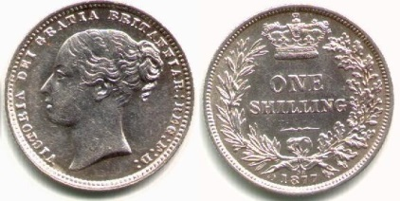1 shilling (1 s)
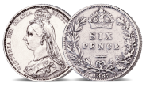sixpence (6 d) | Pre-decimal currency (£ s d):  1 £ = 20 shillings  1 s = 12 pence | In 1852 J.S. Coyne produced a sequel to Box and Cox entitled Box and Cox Married and Settled, in which Cox’s wife turns out to be a former sweetheart of Box.
How to load dice: Place the die in the oven with the number you want up. Or, drill into the plastic and weight it on one side to make that end land down more often. |  | In a sequel by F.C. Burnand, Box and Cox became Don José John Boxos de Caballeros y Carvalhos y Regalias, Count Cornelius de Coxo, Land Margrave of Somewhere, and they live in Salamanca and Venice.
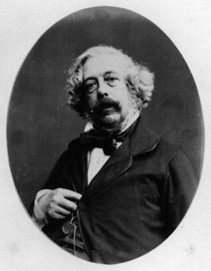Joseph Stirling Coyne (1803-68) |  | In Morton’s model, Labiche’s comédie-vaudeville Frisette, in which the landlady lets one room to a young woman, a lacemaker, and a young man, a baker. – In Arthur Sullivan’s Savoy opera Cox and Box, Mrs. Bouncer is replaced by Sgt. Bouncer.
 |  | Joseph Stirling Coyne was a most industrious writer, and no year passed in which he did not bring out one or more pieces. At the time of his death he was the author of upwards of fifty-five dramas, burlesques, and farces.

